Economic analysis of Scroll mainnet’s dynamics

**Goal:**

Our goal was to draft an economic model for Scroll protocol, considering on-chain data and actual proof costs, in order to have a better understanding of potential revenue of the protocol and the provers. Our analysis also provides an overview of main factors influencing revenue, and helps to understand under which circumstances and on-chain dynamics the provers need to be incentivized.

**Data used for the analysis:**

* The data related to transactions, blocks and batches for period 1 Nov 2023 to 24 January 2024 has been sourced from Scroll explorers (dashboards and csv files).
* The data on how many chunks each batch contains on average has been collected manually by checking 50-100 batches to find the chunk count it includes. An estimated median of 10 chunks per batch was used for the analysis. This could be further fine-tuned if we can receive additional data on this from the Scroll team.
* For the data related to transaction fees we extracted approx. 7K transactions from 29/30/31 Jan 2024 from Scrollscan.
* The proof cost is based on the benchmarks of Zero Computing for the Scroll prover.

**Assumptions:**

1. it takes an equal amount of time to generate a chunk proof and a batch proof and both cost the same to generate
2. all provers are working uninterruptedly

**Variable elements:**

* time to generate a proof – currently 20 minutes per proof
* revenue shared with the provers – currently 100% was used

**Average transaction fees** (based on approx. 7K transactions on 29/30/31 Jan 2024):



* The average L2 execution fee was used to calculate protocol revenue.

**Scenarios analyzed:**

* Base scenario: Averages of the base period
* Scenario 1 – using data on 5 November 2023: Gas utilization, tx count and batch count positively correlate with the average => No change in revenue
* Scenario 2 – using data on 12 Dec 2023: Gas utilization and batch count positively correlate with the average but the tx count is lower => much lower profit (non-linear)
* Scenario 3 – using data on 11 Nov 2023: Gas utilization and batch count positively correlate with the average, but tx count is much higher => linearly higher profit

**Analysis**:

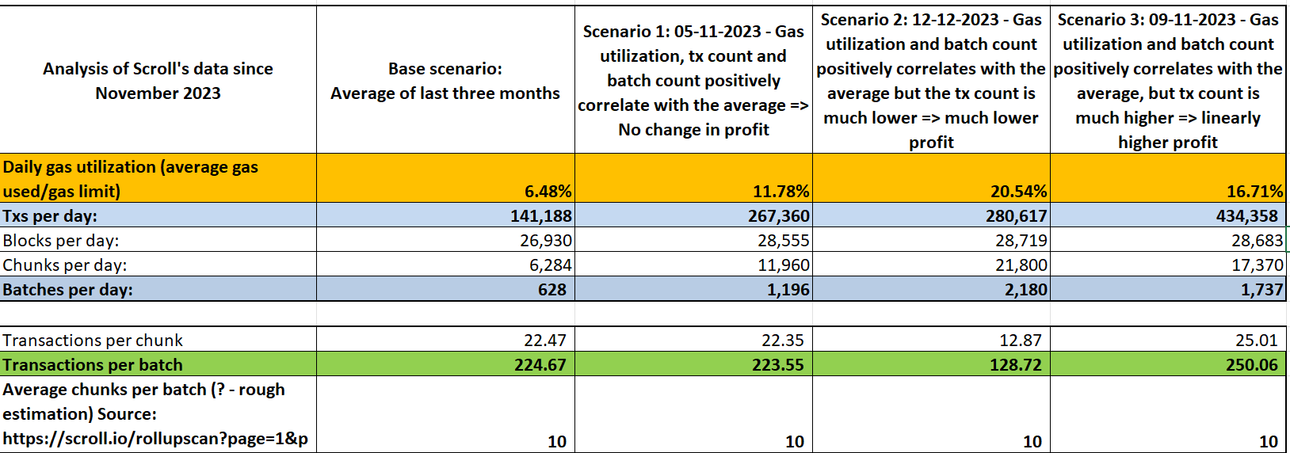

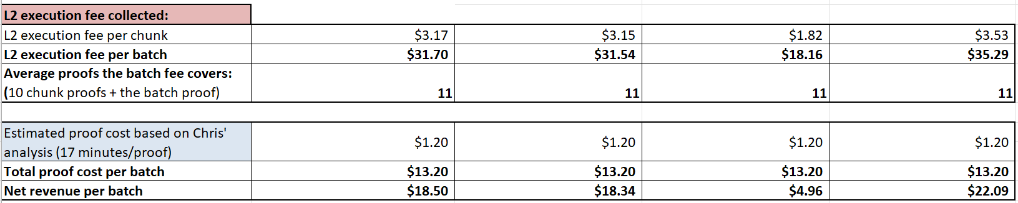

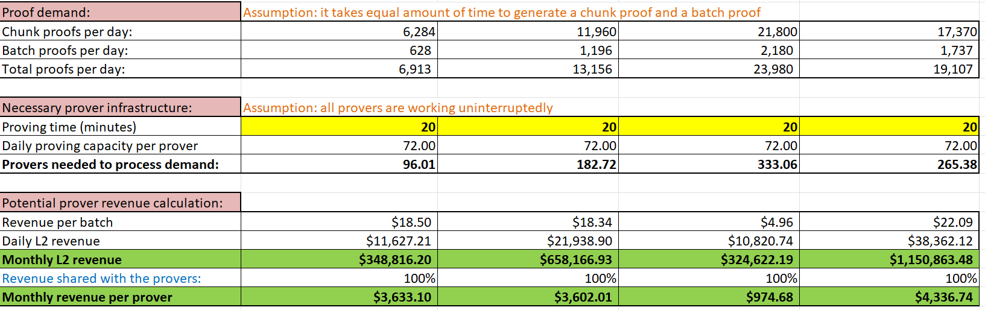

Full analysis:



**Explorations and implications:**

* The data shows that the number of transactions, the number of batches, and the level of gas utilization are in positive, ~linear correlation

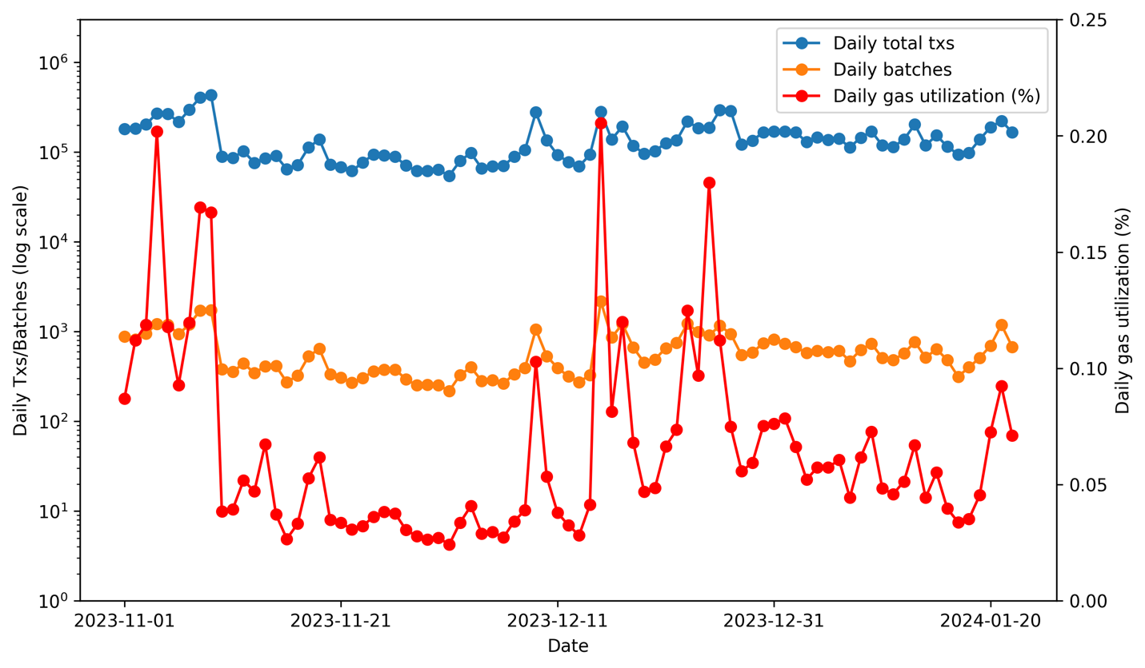

* + Based on this we could estimate Scroll’s theoretic maximum transaction capacity: the current
    - 6.48% gas util. => 141K transactions per day
    - 70% gas util. => 1,52M transactions per day
    - 100% gas util. => 2.17M transactions per day
* Some days show characteristics different from the average
* The block count is almost constant throughout the scenarios and does not influence revenue.
* The batch count ~linearly correlates with the gas utilization and has an almost constant impact on revenue.
* **Main impact factor:** **the transaction count per batch** is a factor with major impact. Batches including proportionally fewer transactions result in an above-linear drop of revenues and profits, while batches with transactions above average result in revenue increase.

**Data supporting the above conclusions:**

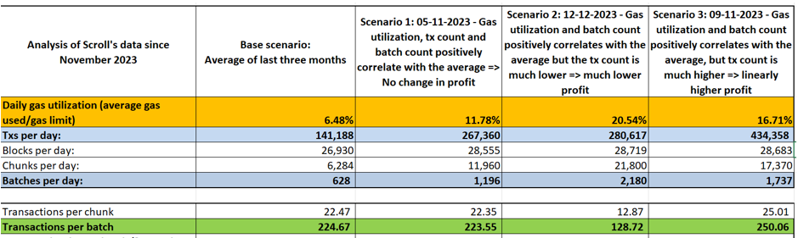

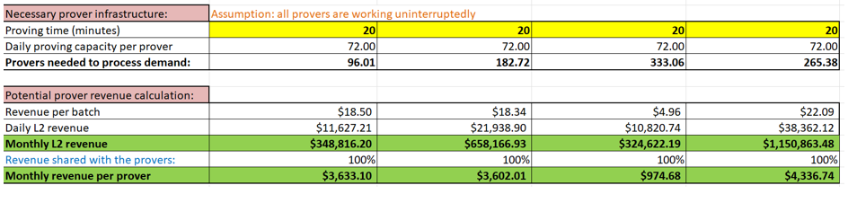

The analysis could provide more accurate insights:

* if we could receive more data for the entire base period, including tx fees (both L2 and L1) and chunks as well
* if the Scroll team could provide more information regarding the necessary compute resource related to chunk proofs vs. batch proofs and any other information needed to estimate the cost and time of proof generation for both of these proofs
* further modeling could be made considering Scroll’s preferred prover coordination mechanism
* further explorations should be made related to those days when the characteristics are significantly out-of-pattern to understand the causes. For instance: 12 Dec 2023, when very high gas utilzation and very high batch count was paired with significantly lower transaction count compared to days with similarly high gas utilization.